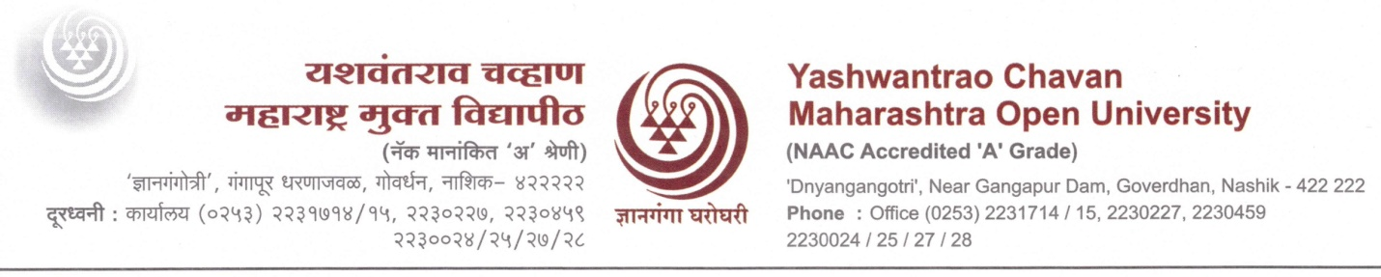

Paste here a signed copy of your recent pass-port size photograph

Advertisement No. YCMOU/EST/2024/02

Name of the post applied for : Professor of Practice
Field/Stream/Area : ……………………………….……

Advt. No ...............................................Date .......................,...

1) Name in Full (IN BLOCK LETTERS): ……………………………...……………………
2) Father's Name: ………………………………………………
3) Mother's Name: ………………………………………………
4) Husband's Name (in case of married Women): ……………………………………………
5) Date of Birth: Day: ……… Month: …………Year: ……………………
(As recorded in the Matriculation or equivalent certificate)
6) Age: .....................
(as on the last date fixed for the receipt of application) : ................years......,,....months
7) Nationality: .....................................
8) Religion: .....................................
9) Marital Status: Married /Unmarried
10) Sex: Male / Female
11) Do you belong to any reserved category? Yes/No: .....................................
lf yes, specify the category (SC/ST/VJ-A/NT-B/NT-C/NT-D/OBC/PWD) with sub Category.

12) lf physically disabled, indicate the relevant particulars :-
Nature of Disability | lf applicable, Write 'yes' | Percentage of disability
a. Blindness or low vision :
b. Hearing impairment
c, Locomotor disability or cerebral palsy (includes all cases of Orthopedically handicapped)

13) Permanent Address: ……………………………………………………………
………………………………………………………………………………………………

………………………………………………………………………………………………

………………………………………………………………………………………………

PIN CODE ………………. Phone No: ………….,.,......... Mobile No…………………

Address for Correspondence: ……………………………………………………………
………………………………………………………………………………………………

………………………………………………………………………………………………

PIN CODE ………………. Phone No: ………….,.,......... Mobile No…………………

Email lD. : ……………………………………………………………………

14) Educational qualifications (Attach additional pages, if required)

Name of the course | Name of the Board / University | Month & Year passed | Division | % of Marks | CGPA (if grading is applicable) | Subjects studied
Name of the course | 1 | 2 | 3 | 4 | 5 | 6
Bachelor's degree
Master's degree
M.Phil. / equivalent
Ph.D.

15) Chronological list of experience (including current position/ employment)

Area of Experience | Post Held | Name of Department | Period of Experience |  | Salary
 |  |  | From | to
1 | 2 | 3 | 4 | 5 | 6

16) Any Other Special Information: (If needed enclose separate sheet to substantiate your candidature in detail.)

I hereby declare that all entries made by me in this application are true, complete and correct to the best of my knowledge and belief. I understand that in the event of any information being found false, incomplete or incorrect, my candidate/appointment is liable to be cancelled/terminated.
………………………………………………………………………………………………………..

………………………………………………………………………………………………………..

17) (a) Reference persons 1)
(With name & Mobile Number)

(b) Reference persons 2)

(Name & Signature of the Applicant.)
Place:

Date:

Format for No Objection Certificate from Employer
(On Letter Head of the Organization)

TO WHOMSOEVER IT MAY CONCERN

This is to certify that Mr. /Ms/ Dr…………………………………………………. S/O/D/O/W/O………………………….. is working as …………………………... (Designation)
in this organization since -------------- (Date). This organization does not have any objection on appointment as Professor of Practice in the department of ……………………..………………of
Yashwantrao Chavan Maharashtra Open University, Nashik – 422 222. In case of appointment as Professor of Practice he/she will be abide by all rules and regulations of the University laid down for he above said post time to time.

Place: Name and Signature of Authority
Date: Office Seal:

