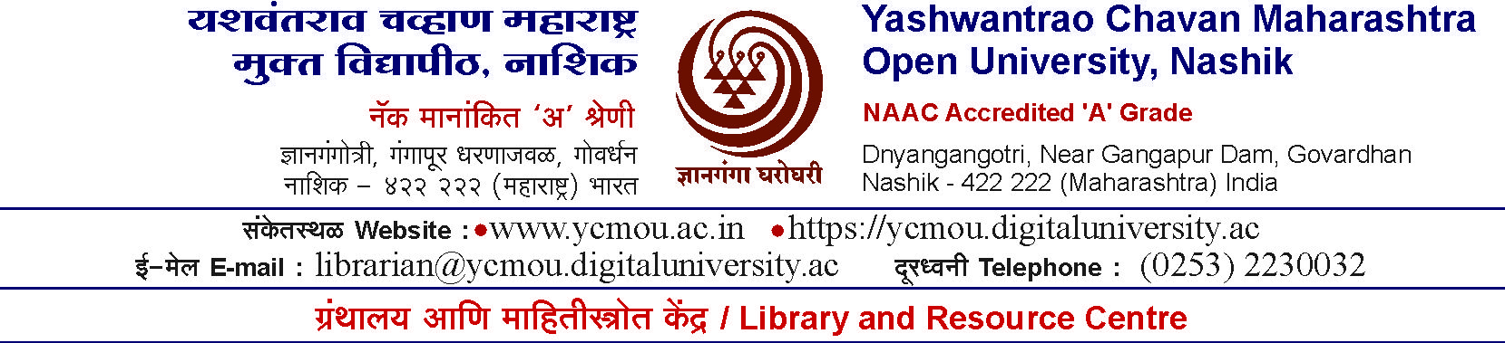

Date:

To,

Sub. — Submitting Trade Terms 2024-25 for the supply of Books and other Reading Materials.
Sir,
University intends to purchase books and other learning material during the year 2024-25
All the interested vendors are requested to submit Trade —Terms in the sealed envelope addressed to the Registrar, Yashwantrao Chavan Maharashtra Open University, near Gangapur Dam, Nashik 422 222-Maharashtra for supplying ’Books and other Reading materials’ to Yashwantrao Chavan Maharashtra Open University Library, Nashik with special reference to the points enumerated in the prescribed form.

A copy of prescribed form is enclosed herewith. The Vendors are requested to submit duly filled copy on or before 2nd July 2024 by post/by hand so as to reach University. (Trade Terms received after due date will not be accepted) The envelope should be superscripted as “Trade - Terms 2024-25 for the supply of Books” in bold letters. Please feel free to contact for any queries on 0253-2230032 or E-Mail : librarian@ycmou.digitaluniversity.ac

Thanking you,

Yours faithfully,

Registrar

Yashwantrao Chavan Maharashtra Open University, Nashik 422 222
Library and Resource Centre

Trade - Terms 2024-25
Name of Bookseller ---------------------------------------------
Registration No. ---------------------------------------------
Address ---------------------------------------------
---------------------------------------------
---------------------------------------------
------------------------------------------------------

Bank Account No. -----------------------------------------------
Name of the Bank/Branch/Place ---------------------------------------------
PAN No. ---------------------------------------------
Telephone No. ---------------------------------------------
Website ---------------------------------------------
E-mail Address
--------------------- Fax No. ------------

Particular |  | Discount No. of Copies
 |  | One copy | *2 to 5 copies | * 6 to 10 or more copies
A.Net Rate for Supplying :-
i.  ii. iii. | Foreign publications
 | Indian publications (English)
 | Marathi, Hindi and other languages
B.Net rate for supplying:-
i. Special publication like (CD’s CBT’s Floppies Audio’s Video’s)
C. Net Rate of supplying:
i.  ii. | Text books of  Maharashtra State Bureau, NCERT etc.
 | Textbooks of all other UG/PG programmes.
- Handling Charges
Please mention Handling Charges (if applicable) in case of short discount /No discount tiHes, if any | Yes | No
If yes please mention charges
%
* Vendors are requested to fill up all the columns in Trade -Term.

*While quoting discount for any category of reading material, do not differentia
Hard Bound/Paper back etc.

E. Specific — Terms relating to following points
Pre-receipt of the Bill- Postage, Packing, Forwarding.
------------------------------------------------------------------------------------------------------------------------------------------------------------------------------------------------------------------------------

F. Mention Mode of Delivery.
-------------------------------------------------------------------------------------------------------------------
-------------------------------------------------------------------------------------------------------------------
-------------------------------------------------------------------------------------------------------------------

G. Annual Turnover of your firm during last three years.
-----Year------------------------Turnover(Annual)------------------------------PAT---------------- ---------------------------------------------------------------------------------------------------------------------------------------------------------------------------------------------------------------------------------------------------------------------------------------------------------------------------------------------
------------Please attach copies of audited statements in support to point G.---------------- ----------------------------------------------------------------------------------------------------------------

H. The list of educational clients like Universities, IIT’s, IIM’s, IISc’s, etc. to whom your firm has supplied learning material.
--------------------------------------------------------------------------------------------------------------------------------------------------------------------------------------------------------------------------------------------------------------------------------------------------------------------------------------------------------------------------------------------------------------------------------------------------------------------------------------------------------------------------------------------------------------------------------------------------------------

I.The Name of Publisher’s agencies and Specification of stock represented by you.
----------------------------------------------------------------------------------------------------------------
----------------------------------------------------------------------------------------------------------------
----------------------------------------------------------------------------------------------------------------
----------------------------------------------------------------------------------------------------------------
----------------------------------------------------------------------------------------------------------------
----------------------------------------------------------------------------------------------------------------

J. List of rare and out of print books available.
Sr.No. Author Title Publisher Year of Publication.
---------------------------------------------------------------------------------------------------------------------
---------------------------------------------------------------------------------------------------------------------
----------------------------------------------------------------------------------------------------------------------
----------------------------------------------------------------------------------------------------------------------

(Additional Information, if any, may please be supplied on separate sheet of page.)

Terms and Conditions:

Please Note that all transactions will be executed subject to the following provision from University side.

- The bills are paid strictly in accordance with the terms and conditions mentioned in GOC. No extra charges like the sales tax, packing, forwarding charges, postage, registration, freight, indemnity or service charges are mentioned in this Trade - Terms, will be necessarily presumed that the prices quoted are inclusive of these charges not specified in the Trade- Terms and claimed in the bill will be deducted from the bills without any information to the vendors.
- The right to reject any order is reserved by the University. Every attempt will, however be made to place order with the reputed vendors who are in a position to quote most favorable terms and to supply books in the wide range of topics, promptly from ready stock.
- The selected vendor/supplier shall regularly inform the University about the status of firm order and supply details.
- The rates of conversion fixed by Good Offices Committee from time prevailing at the time of purchase will be accepted by the library. In case of books on approval the exchange rate prevailing on the date of acceptance will apply.
- As per firm order issued by YCMOU Library if the Vendor fails to supply the required books, a penalty will be charged to the Vendor and it will be calculated on the basis of discount (i.e. If discount is 30% and cost of book is Rs.100/- then penalty will be Rs.30/-) Such penalty will be deducted from the bill of vendor. In case if the vendor has not supplied the bill against supply of books, a notice about the penalty shall be issued to the vendor.
- Pre-receipt of the bill required and payments of outstation suppliers will be made through Demand Draft, e banking after deducting bank charges.
- University will purchase Latest Publications only, and also some rare and out of print books.
- The rate of discount for foreign and Indian publications in English to be fixed to the maximum but it should not be less than 10 % of published price.
- The rate of discount for modern Indian Languages to be fixed to the maximum but it should not be less than 15 % of published price.
- Books will be purchased as per the policy of University.
- In case of ’Short’ and ’No discount’, imported and Indian books, the bookseller may levy handling charges up to 15% on the landed cost of the books. ”Such handling charges should be worked out by calculating actual expenses on postage, packing, insurance etc. minus the discount earned if any by the bookseller. All the documentary evidence to be submitted by the supplier in original to the library in support of his claim for additional charges for ’Short’ and ’No discount’ books.
The above terms and condition (1 to 11) are agreed by us.

Signature and Stamp of Vendor

Trade Term Procedure.

- Trade terms will be opened within three working days after the last date of submission.
- The Librarian will place the trade terms furnished by various vendors/suppliers in the form of comparative statement along with observations before Library Committee.
- Library Committee shall accept the Best Trade Terms.

