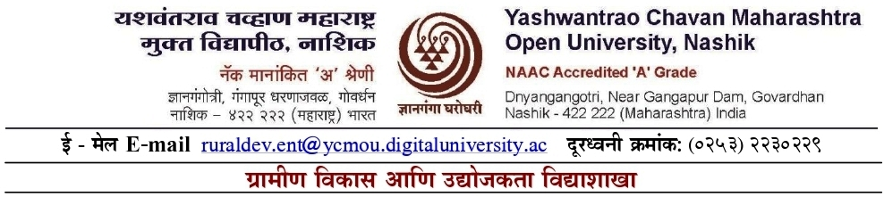

**ग्रामिण विकास व उद्योजकता विद्याशाखा**

**CERTIFICATE COURSE IN FARMER PRODUCER COMPANY MANAGEMENT (C148) TIME TABLE ACADEMIC YEAR 2025-26**

|  |  |  |  |  |  |  |  |  |
| --- | --- | --- | --- | --- | --- | --- | --- | --- |
| SR.NO. | DATE & TIME | 10.00 AM  TO  11.00 AM | 11.00 AM  TO  12.00 NOON | 10.00 AM  TO  01.00 PM | 01.00 PM  TO  02.00 PM | 02.00 PM  TO  03.00 PM | 03.00 PM  TO  04.00 PM | 04.00 PM  TO  05.00 PM |
| 01 |  | INDUCTION PRORAM | | | LUNCH BREAK | INDUCTION PRORAM | | |
| 02 |  | GEN165 | GEN165 | GEN165 | GEN165 | GEN165 | GEN165 |
| 03 |  | GEN165 | GEN165 | GEN165 | GEN165 | GEN165 | GEN165 |
| 04 |  | GEN165 | GEN165 | GEN165 | GEN165 | GEN165 | GEN165 |
| 05 |  | GEN165 | GEN165 | GEN165 | GEN165 | GEN165 | GEN165 |
| 06 |  | GEN165 | GEN165 | GEN165 | GEN165 | GEN165 | GEN165 |
| 07 |  | GEN165 | GEN165 | GEN165 | GEN165 | GEN165 | GEN165 |
| 08 |  | GEN165 | GEN165 | GEN165 | GEN165 | GEN165 | GEN165 |
| 09 |  | GEN165 | GEN165 | GEN165 | GEN165 | GEN165 | GEN165 |
| 10 |  | GEN165 | GEN165 | GEN165 | GEN165 | GEN165 | GEN165 |
| 11 |  | GEN165 | GEN165 | GEN165 | GEN165 | GEN165 | GEN165 |
| 12 |  | GEN165 | GEN165 | GEN165 | GEN165 | GEN165 | GEN165 |
| 13 |  | GEN165 | GEN165 | GEN165 | GEN165 | GEN165 | GEN165 |
| 14 |  | GEN165 | GEN165 | GEN165 | GEN165 | GEN165 | GEN165 |
| 15 |  | GEN165 | GEN165 | GEN165 | GEN165 | GEN165 | GEN165 |
| 16 |  | GEN165 | GEN165 | GEN165 | GEN165 | GEN165 | GEN165 |
| 17 |  | GEN165 | GEN165 | GEN165 | GEN165 | GEN165 | GEN165 |
| 18 |  | GEN165 | GEN165 | GEN165 | GEN165 | GEN165 | GEN165 |
| 19 |  | GEN165 | GEN165 | GEN165 | GEN165 | GEN165 | GEN165 |
| 20 |  | GEN165 | GEN165 | GEN165 | GEN165 | GEN165 | GEN165 |
| 21 |  | GEN165 | GEN165 | GEN165 | GEN165 | GEN165 | GEN165 |
| 22 |  | GEN165 | GEN165 | GEN165 | GEN165 | GEN165 | GEN165 |
| 23 |  | GEN165 | GEN165 | GEN165 | GEN165 | GEN165 | GEN165 |
| 24 |  | GEN165 | GEN165 | GEN165 | GEN165 | GEN165 | GEN165 |

**CERTIFICATE COURSE IN FARMER PRODUCER COMPANY MANAGEMENT (C148) TIME TABLE ACADEMIC YEAR 2024-25**

|  |  |  |  |  |  |  |  |  |
| --- | --- | --- | --- | --- | --- | --- | --- | --- |
| SR.NO. | DATE & TIME | 10.00 AM  TO  11.00 AM | 11.00 AM  TO  12.00 NOON | 10.00 AM  TO  01.00 PM | 01.00 PM  TO  02.00 PM | 02.00 PM  TO  03.00 PM | 03.00 PM  TO  04.00 PM | 04.00 PM  TO  05.00 PM |
| 25 |  | GEN165 | GEN165 | GEN165 | LUNCH BREAK | GEN165 | GEN165 | GEN165 |
| 26 |  | GEN165 | GEN165 | GEN165 | GEN165 | GEN165 | GEN165 |
| 27 |  | GEN165 | GEN165 | GEN165 | GEN165 | GEN165 | GEN165 |
| 28 |  | GEN165 | GEN165 | GEN165 | GEN165 | GEN165 | GEN165 |
| 29 |  | GEN165 | GEN165 | GEN165 | GEN165 | GEN165 | GEN165 |
| 30 |  | GEN165 | GEN165 | GEN165 | GEN165 | GEN165 | GEN165 |
| 31 |  | GEN165 | GEN165 | GEN165 | GEN165 | GEN165 | GEN165 |
| 32 |  | GEN165 | GEN165 | GEN165 | GEN165 | GEN165 | GEN165 |
| 33 |  | GEN165 | GEN165 | GEN165 | GEN165 | GEN165 | GEN165 |
| 34 |  | GEN165 | GEN165 | GEN165 | GEN165 | GEN165 | GEN165 |

*Note: Honorarium of Rs. 250/- for a Counselling Session of 01 Clock Hour and Rs. 500/- for a Session of 02 clock Hours be given to a counsellor.

**Director (I/C)**

**School of Rural Development & Entrepreneurship**