Curriculum Vitae for Academic Consultants & Coordinators

CURRICULUM VITAE
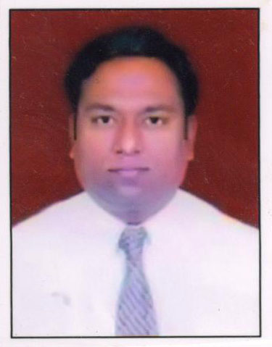Photo

Name: Mr. Manish Sarjerao Shingare
Designation: Academic Coordinator (Physics)
Mobile: 8888948182
E-mail: manish.shingare1985@gmail.com

Education:

Doctor of Philosophy | University:…………………..  Discipline: ……………………  Year of Passing………………….  Research Topic:……………………..
Master of Philosophy | University:…………………..  Discipline: ……………………  Year of Passing………………….  Research Topic:……………………..
Master of Science | University: Savitribai Phule Pune University, Pune  Discipline: Physics  Year of Passing: 2008  Research / Dissertation Topic:………………………
Bachelor of Science | University: Savitribai Phule Pune University, Pune  Year of Passing 2006
Bachelor of Education | University: Savitribai Phule Pune University, Pune  Year of Passing 2021

Work Experience:

Position held | Name of the Organization / Institution | Duration |  |  | Responsibilities Performed
Position held | Name of the Organization / Institution | From | To | Years | Responsibilities Performed
Lecturer | K. K. Wagh Polytechnic, Chandori | 2009 | 2018 | 09 | Conduction of Exam, Admission Incharge, Student Counselling, etc.
HR Assistant | K. K. Wagh Institute of Engineering and Research, Nashik. | 2018 | 2021 | 03 | Work related to annual increment, verification of different types office order, verification of entry in service books of staff and all other related office work.
Academic Coordinator  (Physics) | YCMOU, Nashik | 2022 | Till date | 1 month | Preparation of M. Sc. syllabus

Publications:

Sr. No. | Title of the Research Paper | Name of the Journal / Publisher | Year of Publication

Official Address:
School ofArchitecture, Science and Technology,
Yashwantrao Chavan Maharashtra Open University,
Nashik – 422 222. Maharashtra, India

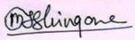

Signature of the Candidate

