Yashwantrao Chavan Maharashtra Open University Nashik

URL: University website : https://ycmou.ac.in/about_department/index/26
Library and Resource Center
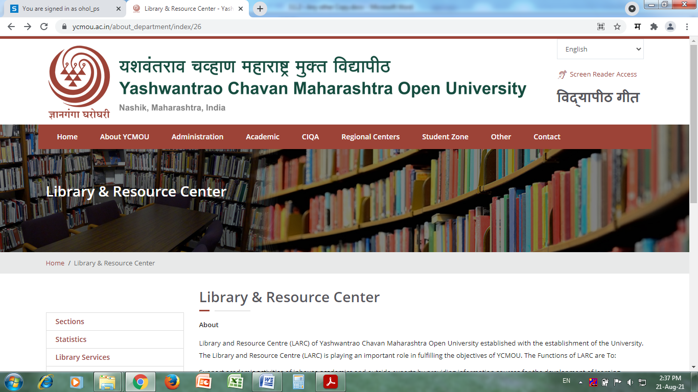

E-Resources available at University campus
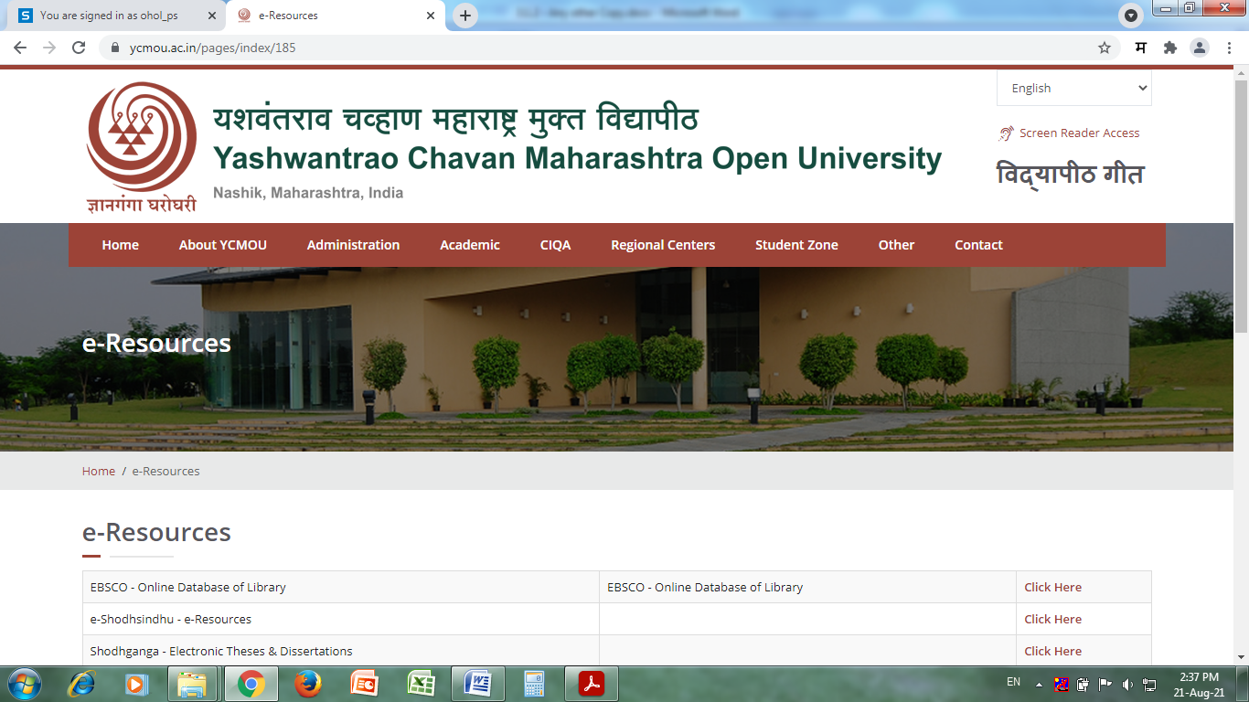
URL: https://ess.inflibnet.ac.in/eres.php?memID=179
1.EBSCO
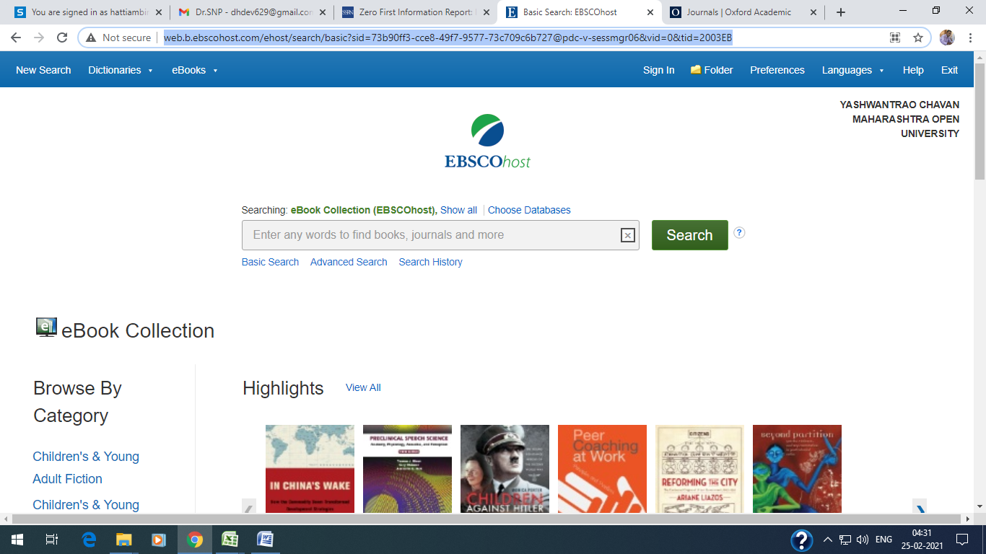
URL: http://web.a.ebscohost.com/ehost/search/basic?sid=c00b5ce5-f9ae-43e1-b157-0c3b3f592b78@sdc-v-sessmgr02&vid=0&tid=2003EB
2. E-Shodh Sindhu Consortium for Higher Eduction E-Resources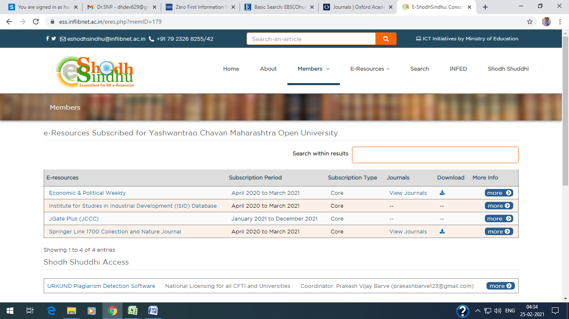
URL: https://ess.inflibnet.ac.in/eres.php?memID=179
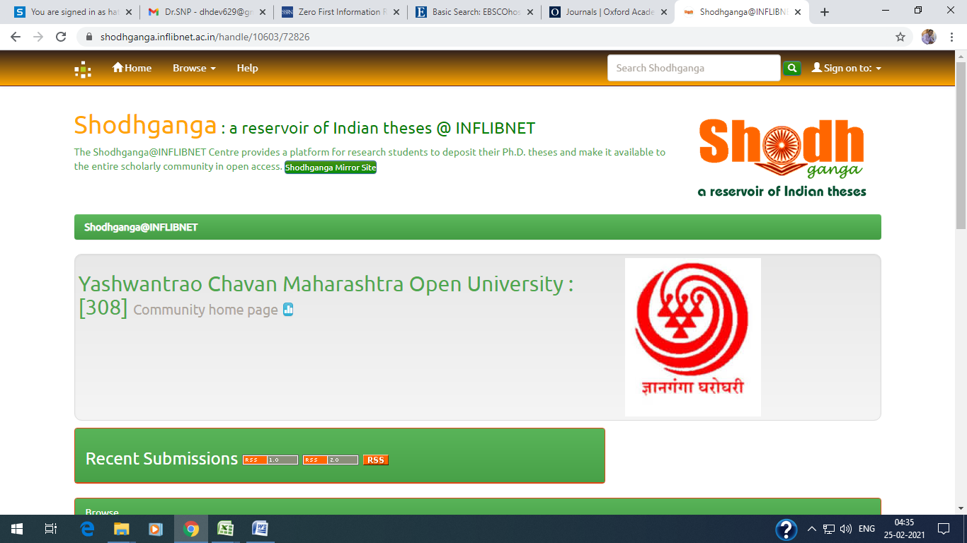
URL: https://shodhganga.inflibnet.ac.in/handle/10603/72826

4. Urkund (Ourginal)

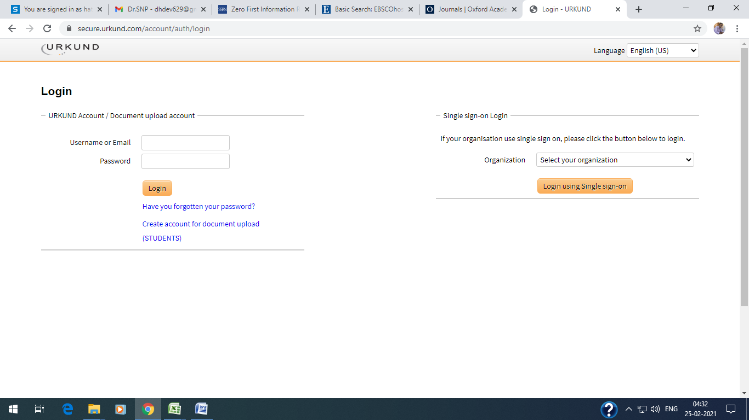

URL: https://secure.urkund.com/account/auth/login

5. VIDEEYA Portal 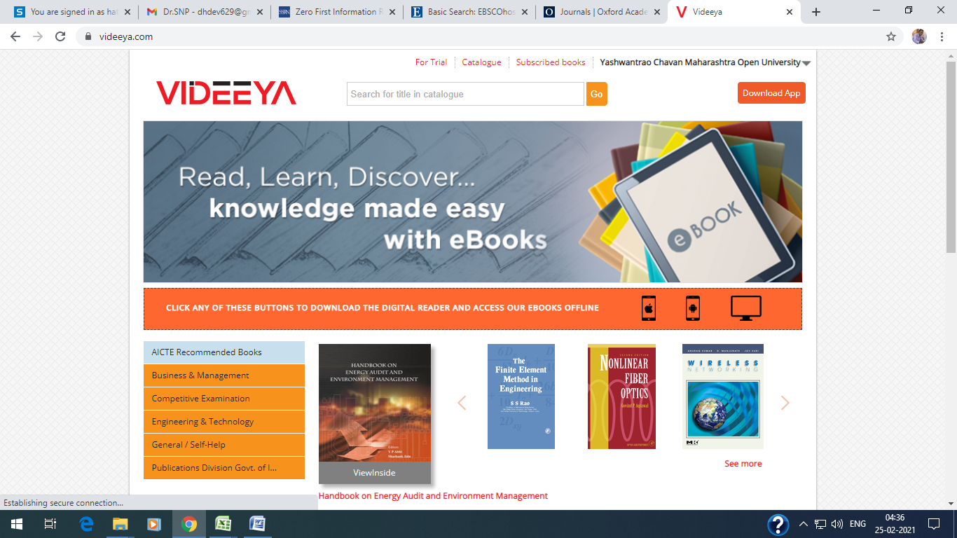
https://videeya.com/
6. DELNET - Full-text Digital Library Resources
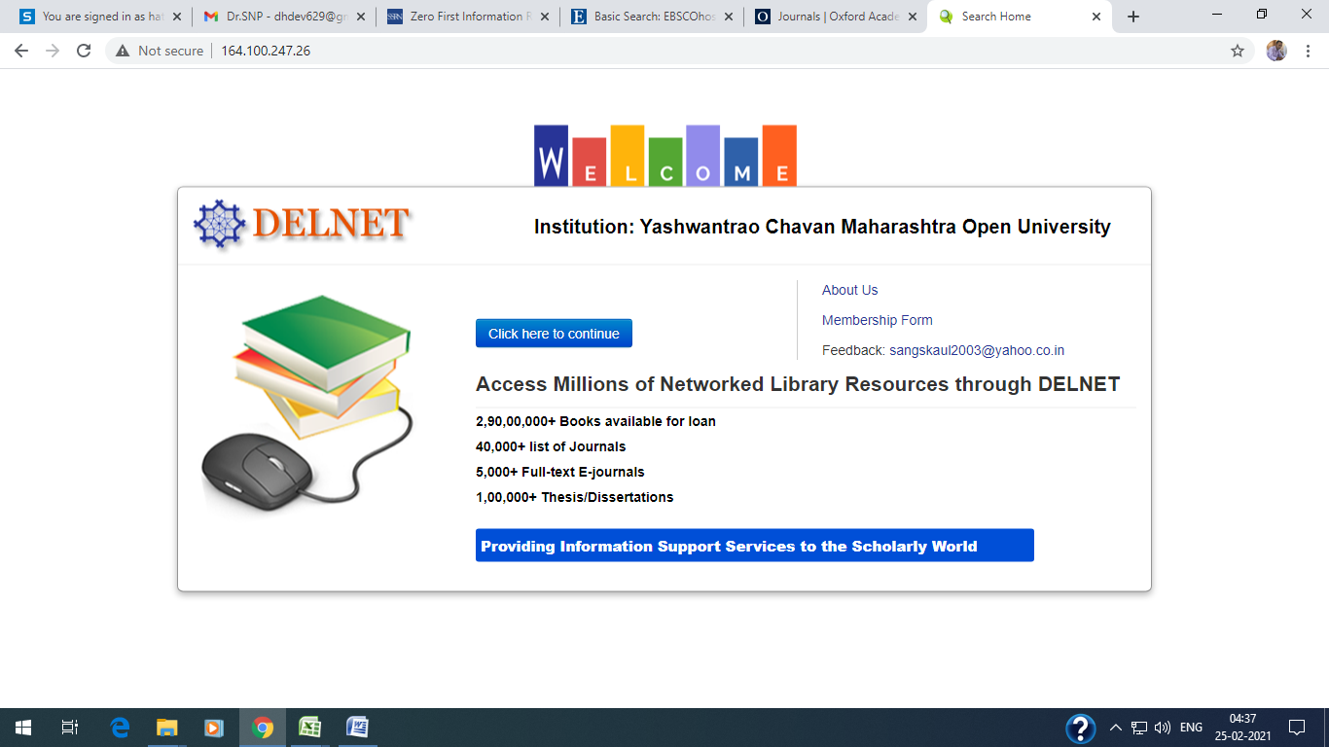
http://164.100.247.26/

7. INDCAT Online Union of Indian Universities
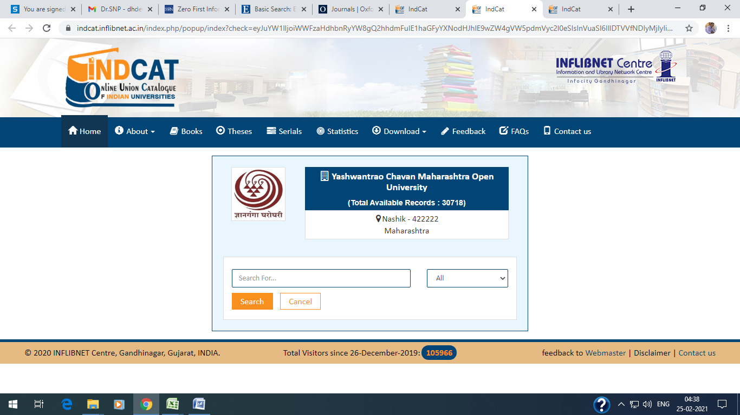
https://indcat.inflibnet.ac.in/index.php/popup/index?check=eyJuYW1lIjoiWWFzaHdhbnRyYW8gQ2hhdmFuIE1haGFyYXNodHJhIE9wZW4gVW5pdmVyc2l0eSIsInVuaSI6IllDTVVfNDIyMjIyIiwidmFsIjozMDcxOH0=

