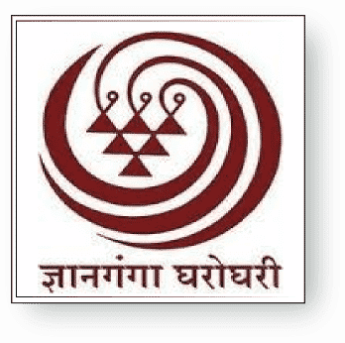 | Yashwantrao Chavan Maharashtra Open University Nashik

3.7.1 Collaborative activities
https://ycmou.ac.in/media/post_image/6a3b6ebe758ea5a4aab4296e1cdb8b6f.pdf

